ASSIGNMENT-2(Individual Task)

Hindanjali Harwanshi CS20M025

(Group-4)

XPATH

1. To print all the food items offered by all restaurants

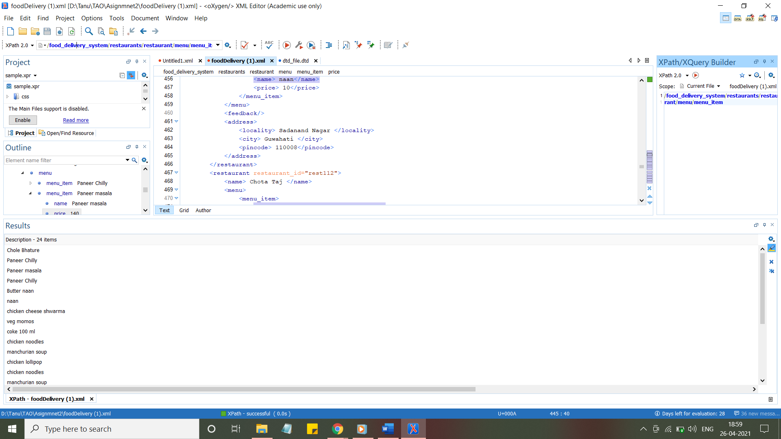

2. To print the users whose payment mode is online and status is paid

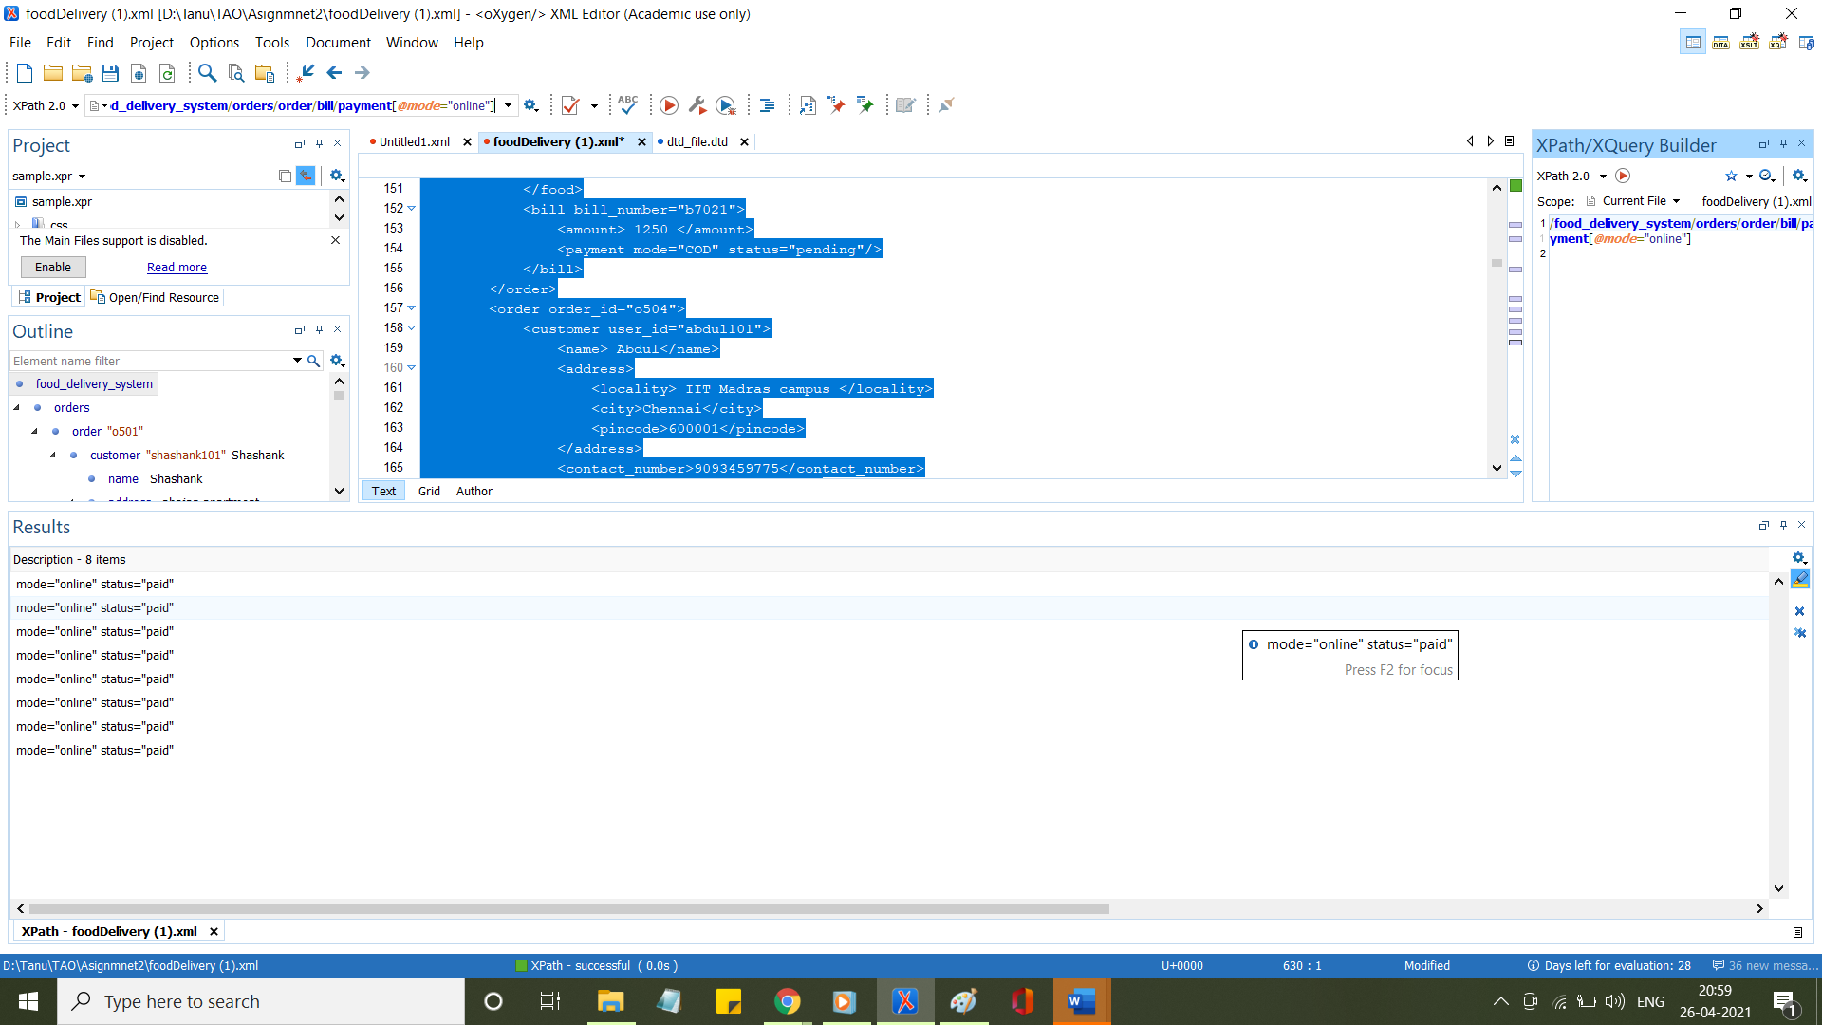

3.To print the first food item of all restaurant present in the restaurants

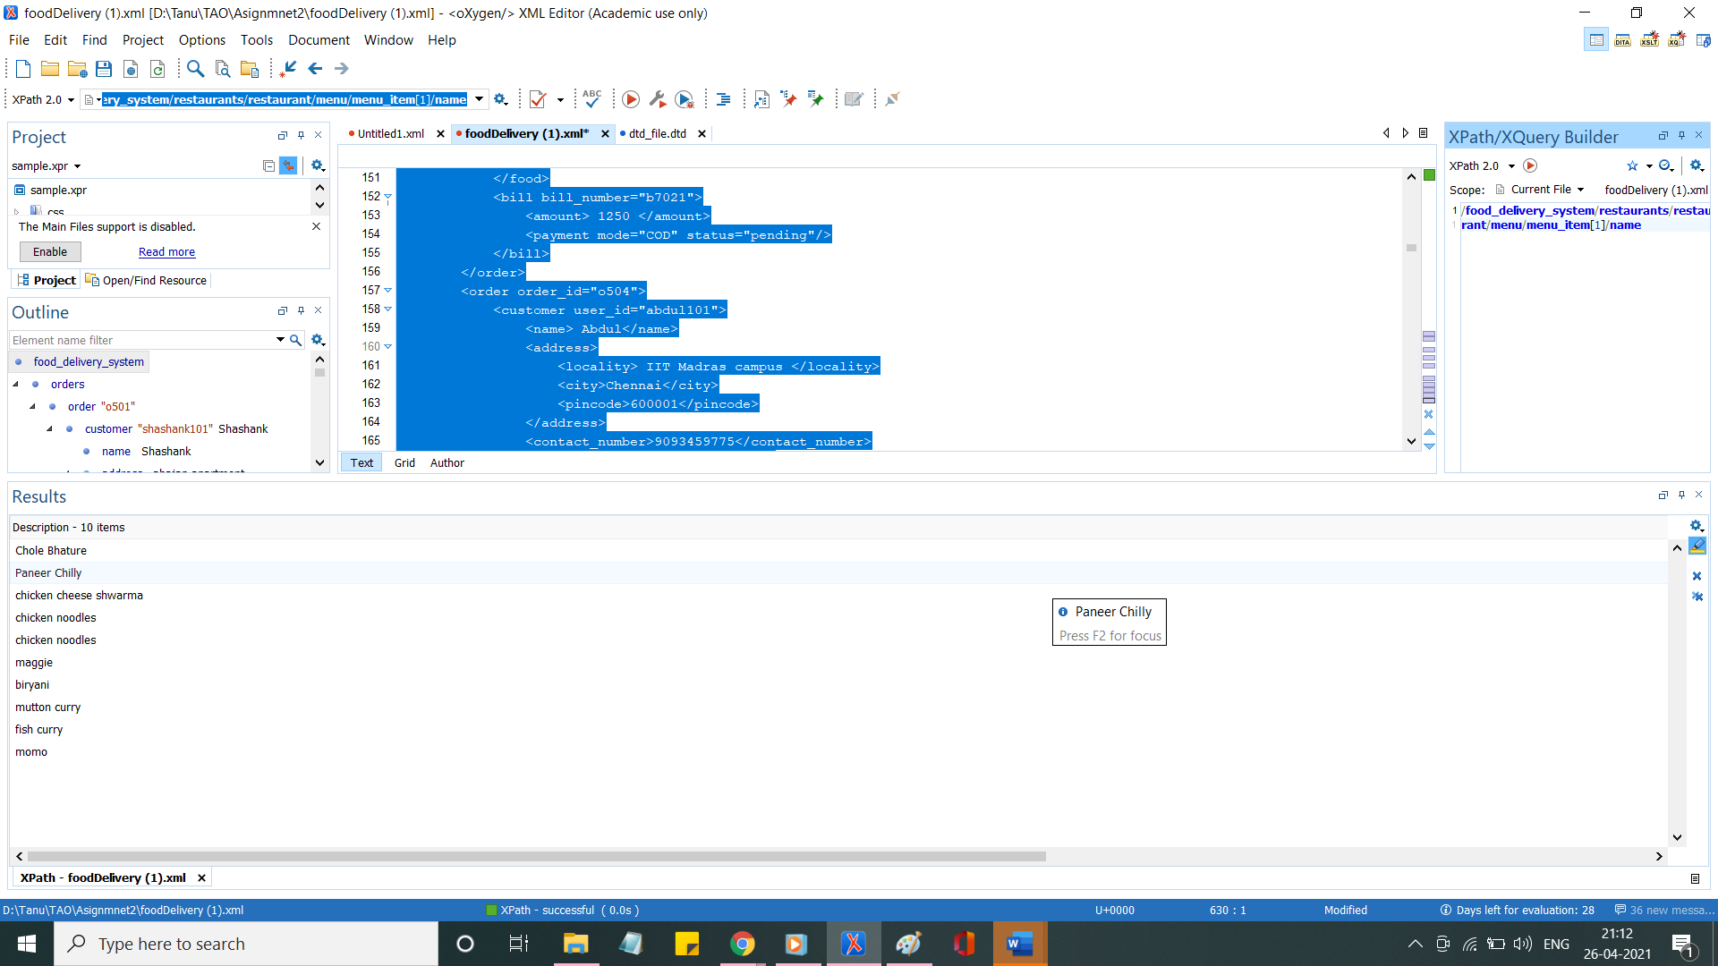

4.To print the quantity of food items in 5th order

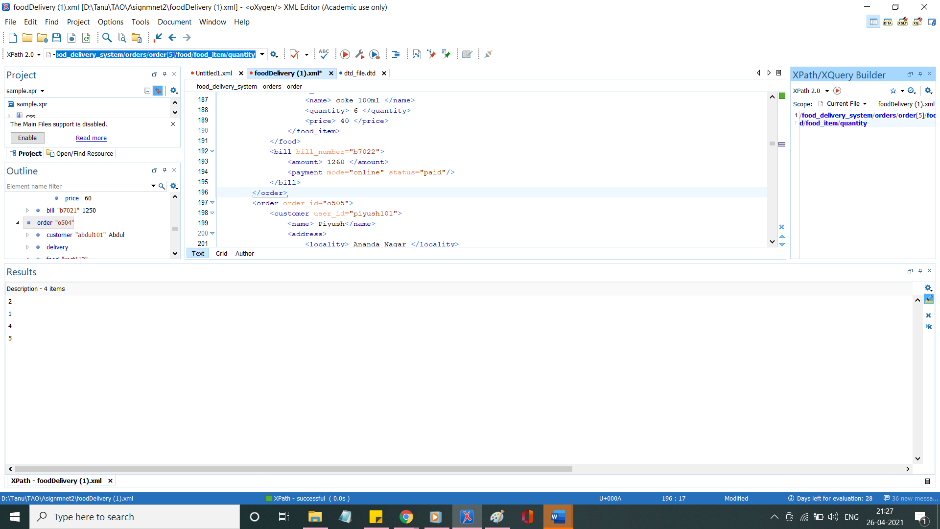

Xquery

1.To find the restaurants which are present in city jabalpur

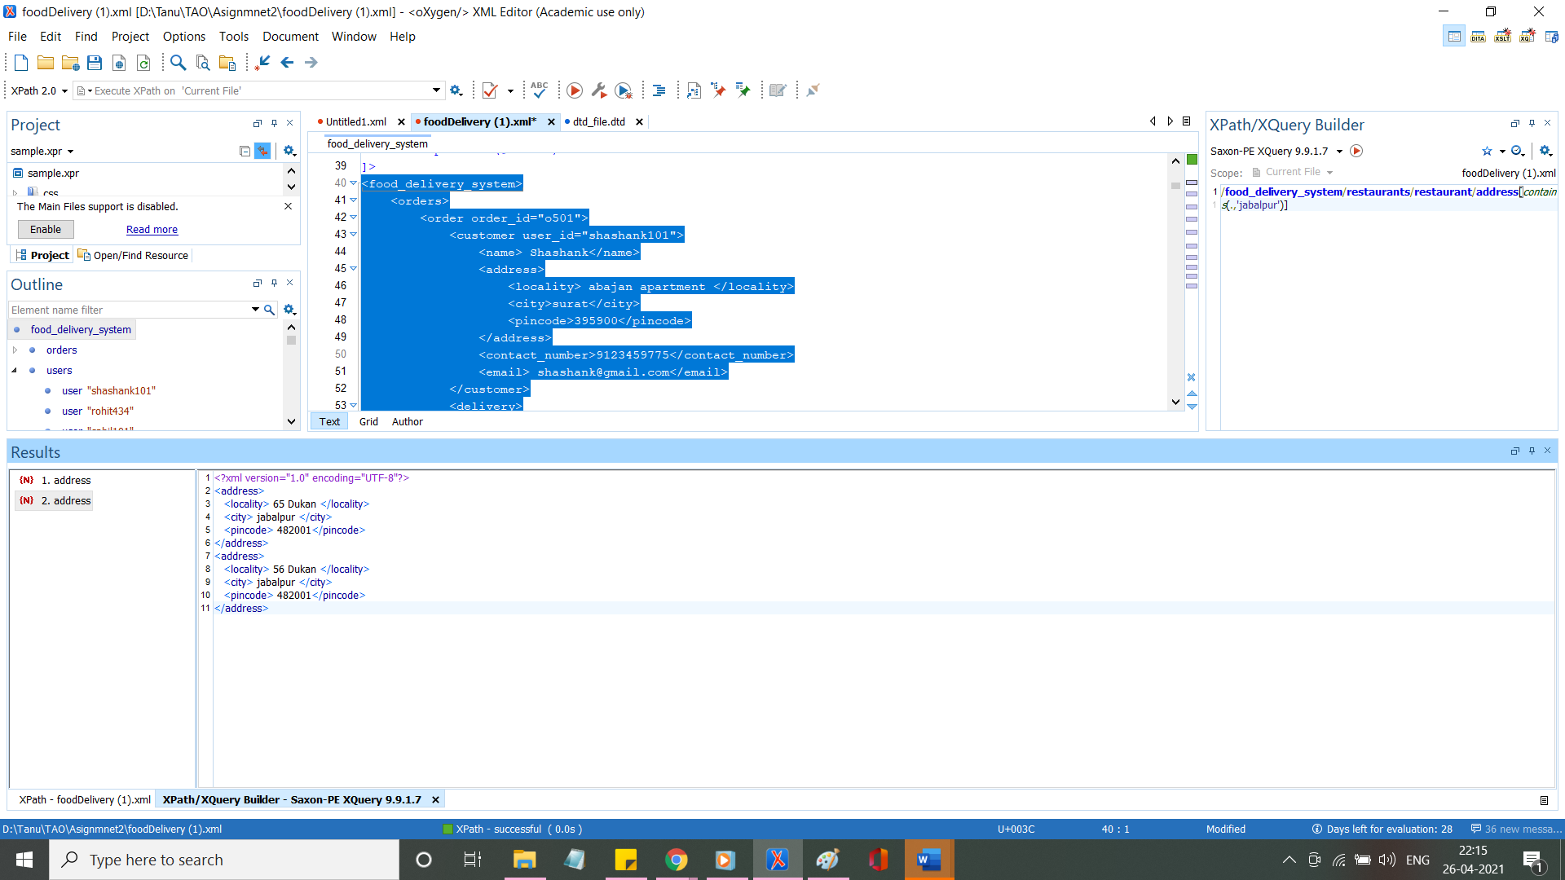

2.To find the delivery boy whose rating is greater >=3

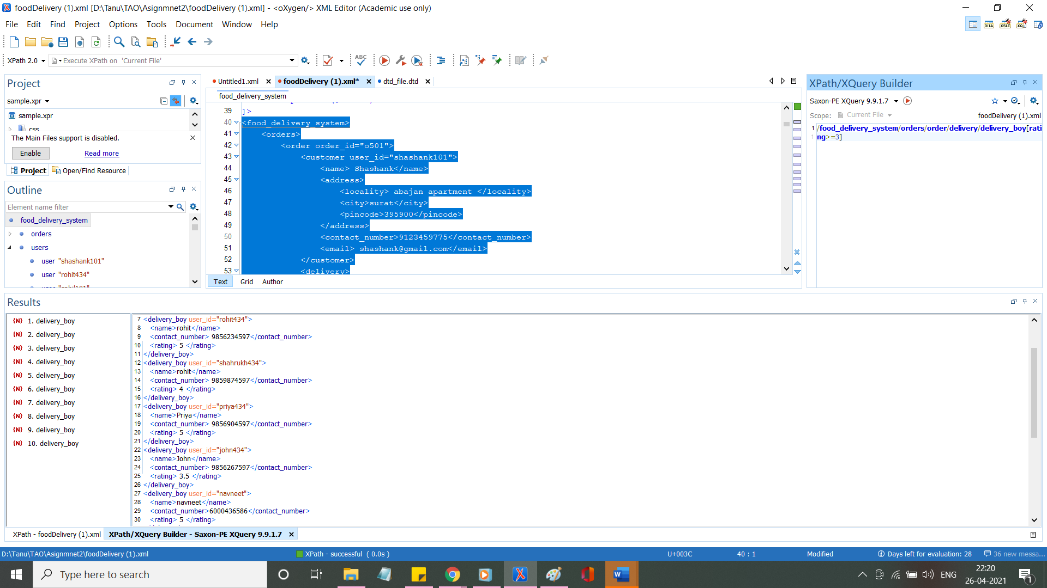

3.To find the second child of the third order child of orders

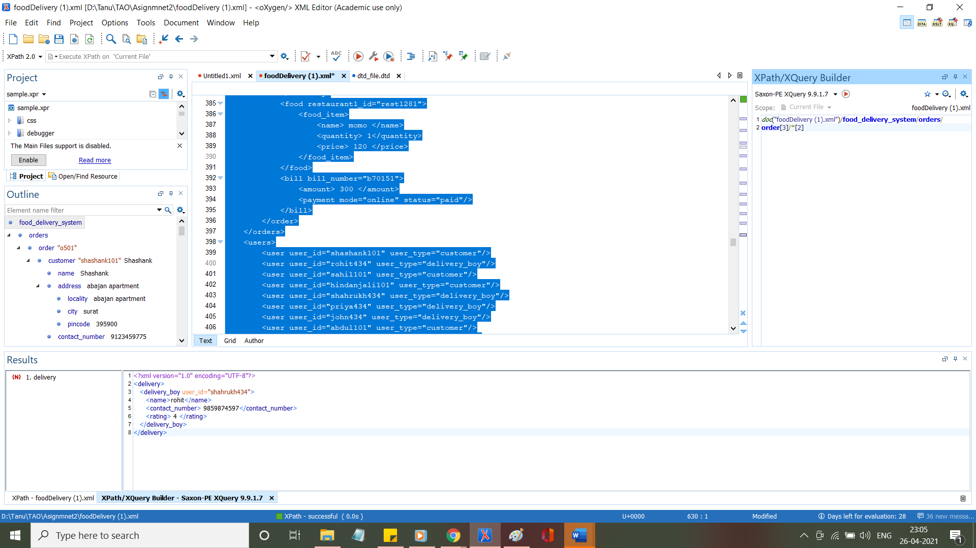

4.To find the last order placed in orders

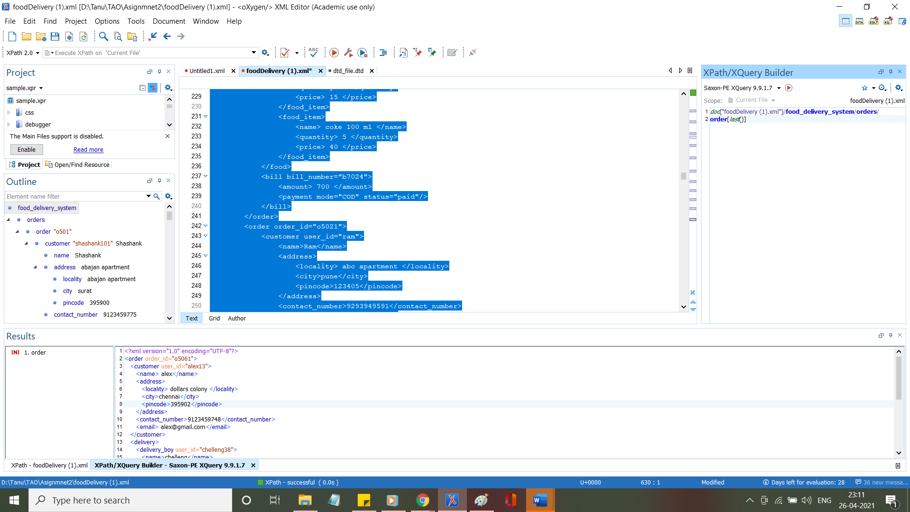

5.To find the name of food items whose price is less than 100

